3.Vacuum Cleaner Problem
Aim
To simulate a Vacuum Cleaner Agent.
Objective
To clean all dirty rooms.
Algorithm
- Check current location.
- If dirty, clean.
- Move to next room.
- Repeat until all rooms are clean.
Flowchart
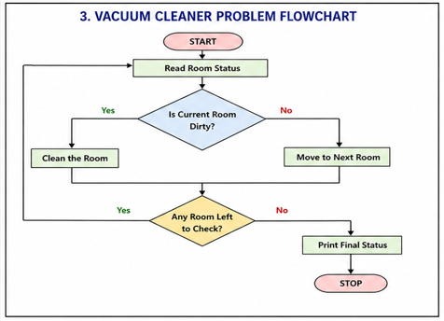
Python code:
# Vacuum Cleaner using DFS

graph = {
'A': ['B', 'C'],
'B': ['D'],
'C': [],
'D': []
}

status = {
'A': 'Dirty',
'B': 'Clean',
'C': 'Dirty',
'D': 'Dirty'
}

visited = set()

def dfs(room):
if room in visited:
return

visited.add(room)

print("Visiting:", room)

if status[room] == "Dirty":
print("Cleaning", room)
status[room] = "Clean"

for next_room in graph[room]:
dfs(next_room)

dfs('A')

print("\nFinal Room Status:")
for room in status:
print(room, ":", status[room])
output:
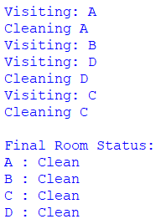
Result
All rooms were cleaned.
Conclusion
The Vacuum Cleaner Agent successfully achieved its goal.

